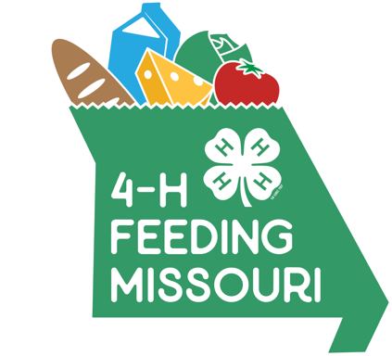
News release – February 2019
4-H Feeding Missouri Food Drive
[insert county or club name here]
This February, Missouri 4-H is partnering with Feeding Missouri in a first-of-its-kind statewide food drive. All of the state’s more than 1,600 4-H clubs, serving youth ages 5 to 18, are invited to participate.
Here’s how [INSERT NAME of CLUB] is contributing to the goal of raising 1 million meals for food banks and pantries statewide!
Who: e.g., [NAME of 4-H Club, name and contact information for club leader or parent volunteer.]
What: 4-H Feeding Missouri food drive. [Insert brief but full description of your event here. Below is a made-up example to give you an idea of what to include.]
[Example only]
The [NAME 4-H of Club] will be volunteering at the [NAME of food pantry or organization] as part of our county’s participation in the statewide 4-H Feeding Missouri food drive. Youth ages 5 to 18 will bring in donations they have collected so far and help pantry staff sort and pack give-away boxes. Youth will be available to interview about the food drive and the impact of hunger in [NAME] County.
Where: [Exact name and address of location.]
When: [Exact times people will be doing the activity.]
Why: To help fill the shelves of our local food pantry and spread awareness of how widespread hunger is in Missouri.

Jan. 29, 2019

4-H Feeding Missouri statewide
food drive — Feb. 1–28, 2019

This February 2019, Missouri 4-H is partnering with Feeding Missouri in a first-of-its-kind statewide food drive. All of the state’s more than 1,600 4-H clubs, serving youth ages 5 to 18, are invited to participate.

From Feb. 1-28, 4-H’ers across Missouri will engage in a friendly service competition to see which clubs can contribute the greatest amount of food, cash contributions and volunteer hours. The goal is to raise 1 million meals for food banks and pantries statewide.

Through local food drives, fundraisers and educational events and presentations, 4-H’ers will also help raise awareness about hunger and food insecurity in Missouri where one in five children live in families that struggle to put enough food on the table.

“We are thrilled to be partnering with Missouri 4-H,” said Scott Baker, state director for Feeding Missouri. “We hope the young people involved in this effort will be inspired by the knowledge that their volunteer hours and the food and funds they collect will have a massive impact in their communities and throughout our entire state.”

The idea for the statewide collaboration came about last year during a conversation between Chris Baker, Feeding Missouri’s resources development manager, and Marshall Stewart, University of Missouri Vice Chancellor for Extension and Engagement. Both saw an opportunity to impact this issue through a partnership, and 4-H volunteered to lead the effort on MU Extension’s behalf.

“This project is a great example of the way University of Missouri Extension can mobilize, engage and work with local partners to improve the lives of Missourians across our state,” Stewart said. “I’m proud of our 4-H youth and their leaders and their commitment to take on this challenge.”

As part of that challenge, Scott Baker and Stewart have agreed to dye their hair green if 4-H’ers meet the 1 million goal. See them accept that challenge here.

Feeding Missouri is a coalition of Missouri’s six major food banks that work to provide hunger relief to every county in the state and the St. Louis City through a coordinated network of more than 1,500 community-based feeding programs.

Major support for 4-H Feeding Missouri is provided by MFA, Inc., the Missouri 4-H Foundation, Sharon K. Strubberg, Sydenstricker Implement Co., Farm Credit Southeast Missouri and Vivayic, Inc.

For more information about the drive, how to get involved and how to contact local clubs to see what they have planned throughout February, visit the 4-H Feeding Missouri site.

It's all about Missourians helping Missourians fight hunger.

Questions? Contact:
Curt Wohleber, University of Missouri Extension News, 573-882-5409, WohleberC@missouri.edu
Anne Reeder, 4-H Feeding Missouri project lead, reederaj@umsystem.edu
Monica Palmer, Feeding Missouri communications manager, monica@feedingmissouri.org

